#include<stdio.h>
void main()
{
printf("Odd numbers between 20 to 40:\n");
for(int i=3;i<=10;i++)
{
if(i%2!=0)
{
printf("%d\n",i);
}
}
}

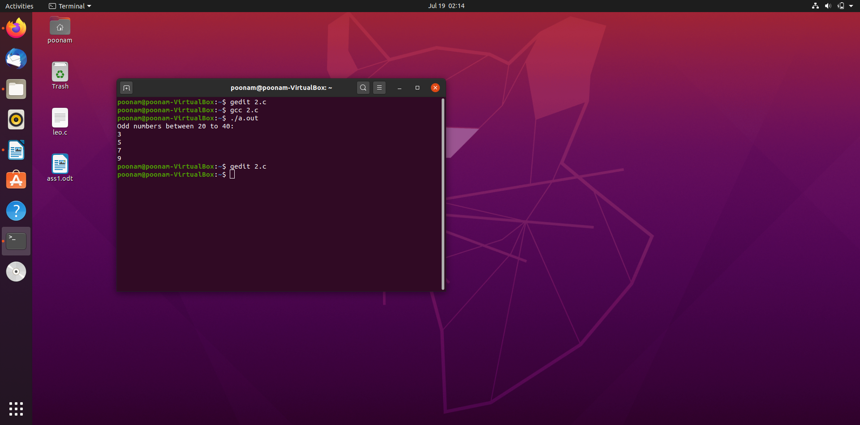
output:

